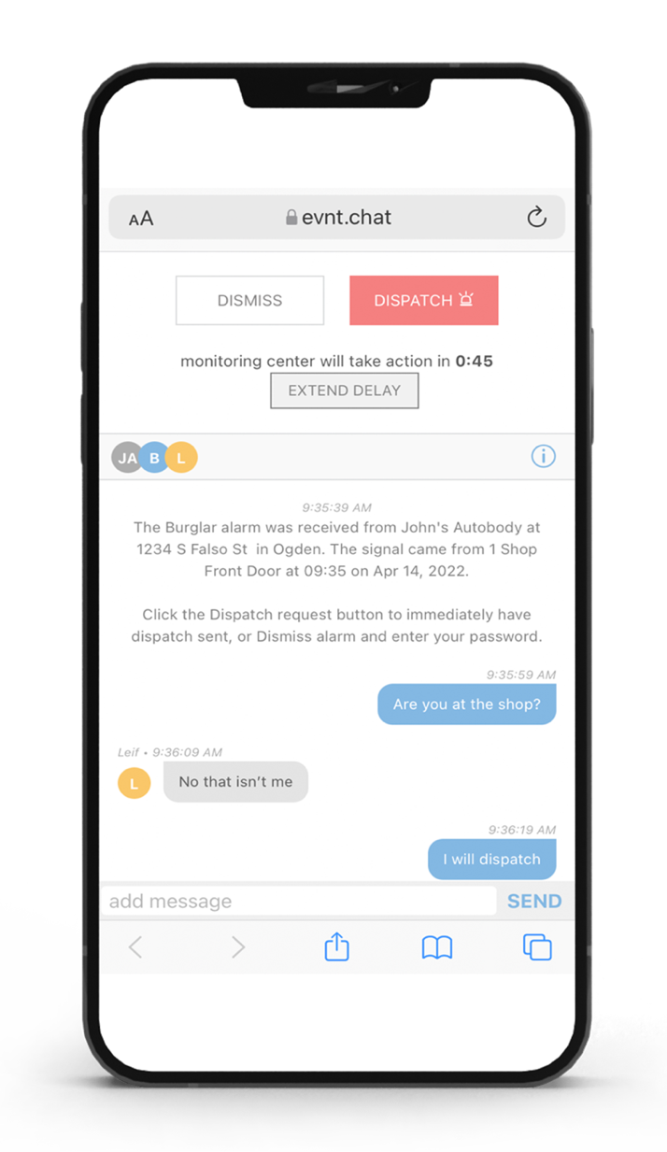

Alarm Validation
Service

Why Chat
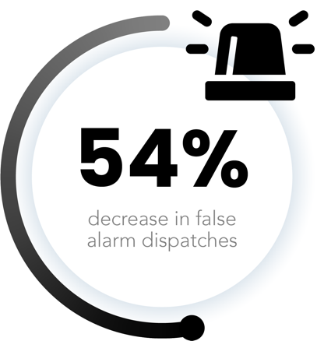
Your alarm goes off, but you can’t answer the phone — what do you do? [name of co.] Chat allows you to quickly confirm or disregard alarms with your contact list via text without having to answer the phone! It reduces the potential for false alarm dispatches and allows you to communicate in the way you prefer.

How it Works

A link is sent to you via text that creates a secure chat group with all members on your contact list to validate an alarm. Members in the group chat can then text one another to determine if dispatch is needed. It’s fast, effective, and simple.

Contact Info here

